III. DOCUMENTATION OF CURRENT SYSTEM

3.1 DESCRIPTION OF THE CURRENT SYSTEM

Basically, GoT HuB? Internet Shop’s procedures are done manually. All logs are done manually. The flow of their process is as follows as stated himself by Mr. Jerome Banda, proprietor:
1. All clients are walk-in.
2. Our staff asks a customer what we could do for them.
3. If client wants to use the internet, he/she will be escorted by our staff to the available PC, as well as offer assistance.
4. If customer just needs printing, staff asks for document to be printed and proceeds to print.
5. If customer just needs scanning, staff asks for document to be scanned and proceeds to scan.
6. If customer just needs media storage, staff gives media storage after payment.
7. Most of the services are post paid, staff shall ask for client’s payment after they have finished renting of after a service has been done.
8. Staff writes down the corresponding code in the shop’s logs alongside the appropriate amount.
9. At the end of the day, accounting is done manually, verifying the cash flow for the day.
At the event that there are no available PCs to be used, the staff asks the client if he/she wishes to wait until another client finishes. If the client agrees to wait, he/she is issued a waiting stub as shown in Figure 2.

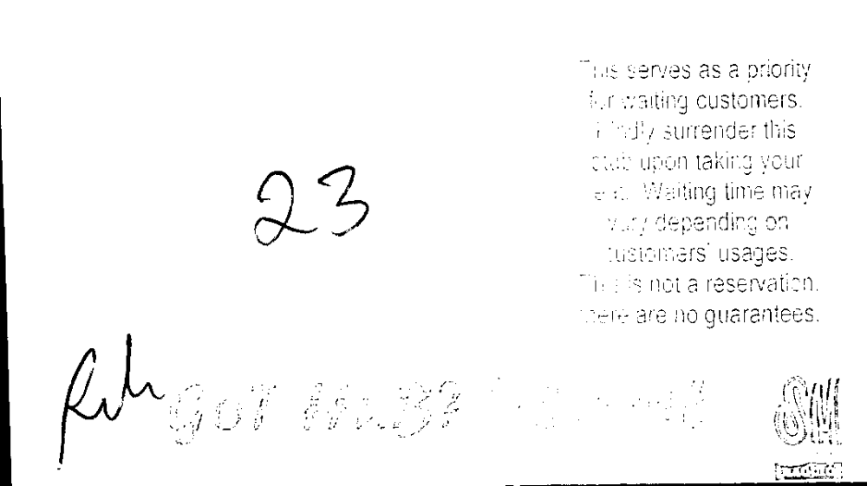
Figure 2.1 Sample Waiting Stub Issued to Clients

This serves as a priority
for waiting customers
Kindly surrender this
stub upon taking your
seat. Waiting time may
vary depending on
customer’s usages.
This is not a reservation.
There are no guarantees.
Waiting List Number
Authorized Signature



It is under the law that business establishments should issue receipts to its clients fro services twenty pesos (PhP 20.00) and GoT HuB? Internet Shop abides in this law. However, if the client requests for a receipts for services below that amount, the staff would issue them likewise. Figure 2.1 is a sample receipt issued by GoT HuB? Internet Shop.

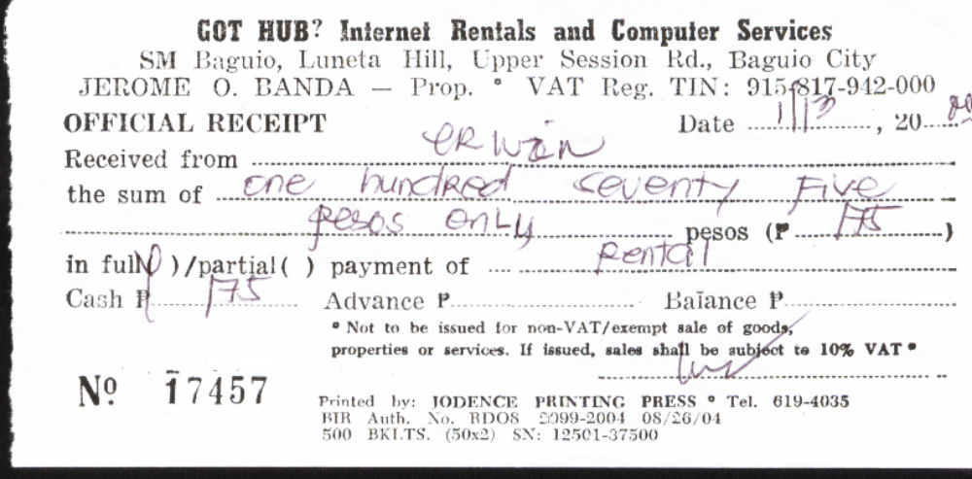
Figure 2.1 Sample Receipt for GoT HuB? Internet Shop
GoT HuB? Internet Shop offers the following services with its corresponding rate as shown in Table 1.
Table 1 Service Rate of GoT HuB? Internet Shop
SERVICE | RATE
Computer Rental per Hour  Per 10 minutes excess | P 30.00  P 5.00
Computer Rental per hour With Webcam  Per 10 minutes excess | P 40.00  P 7.00
Printing – Black (text) per page  Colored (text) per page  Draft  Normal  High | P 10.00  P 20.00  P 40.00  P 50.00
Scanning per document | P 20.00
Typesetting per page | P 30.00
CD Burning (CD not included)  With CD | P 90  P 110.00
Photocopying per page  Standard Paper size  Large Papers | P 2.00  P 5.00
Fax  Local/Domestic/National per minute  International per minute | P 10.00  P 40.00
3 ½ Floppy Diskette (without case) | P 15.00
CD-R | P 20.00
Ragnarok Card 50 | P 50.00

GoT HuB? Internet Shop boasts that 100% of their employees are computer literate and they are able to keep up with the change of technology. With these two strengths among the many, they are given the opportunity to respond to the requests of their clients and to better their performance respectively.
With much strength to be proud of, weaknesses thus leading to threats are still present in the shop. Due to the scenario of open security, manual computation of bills and occurrence of human errors from time to time, less income, inaccuracy and distrust often serves as consequences.
3.2 HARDWARE SET-UP
A. Computer Specifications
Server
---512 MB of RAM
---Pentium 4 Processor
---2.4 GHz
---80 GB
Workstations
---256 MB of RAM
---Pentium 4 Processor
---2.0 GHz

